Use-Case Realization Report (Analysis)
Dispense Drink

Issue 3.0
Revision History
Date | Issue | Description | Author
13 July 2000 | 1.0 | First Issue | Howard Russon
2 August 2001 | 2.0 | Revised for MTech Unit 3 in 2001 | Howard Russon
21 July 2004 | 3.0 | Revised for MTech Unit 3 in 2004 | Howard Russon

Table of Contents
1. Brief Description 4
2. Flow of Events 4
2.1 Standard Flow 4
2.2 Exceptions 4
3. Interaction Diagrams 5
3.1 Collaboration Diagram: Dispense Drink 5
4. Participating Objects 5
5. Class Diagrams 7
5.1 Class Diagram: Dispense Drink 7
6. Derived Requirements 9

Use-Case Realization Report
Dispense Drink

Brief Description
This abstract use case enables the selected brand to be dispensed to the Customer.

Flow of Events
The standard flow of events for this use case and any exceptions are described in the following subsections. The events are described in terms of Actors and Analysis Objects.

Standard Flow
This use case is used by use case Coin Input and Select Brand through Transaction Controller to dispense a drinks can to the Customer. The flow of events is shown in section 3.1 and described as follows:
- To initiate this use case, the Dispense Controller will be instructed to perform operation DispenseDrink using the identity of the drink item (brand) passed on by the Transaction Controller. The Dispense Controller then will use operation Release of the Drinks Store to dispense the required drink.
- The operation Release will check and decrement by one the Drink Store Item which stores the total stock quantity of the selected brand.
- The Dispense Controller will then use its own operation UpdateDrinkSelection to display the latest stock and price information on the Drink Selection Box for the selected brand as follows:
- Operation GetStock of the Drinks Store will be used to find the current stock level of the brand.
- Operation GetPrice of the Drinks Store will be used to find the price of the brand.
- Operation Update of Drink Selection Box will be used to display NO STOCK messages and drink prices on the Drink Selection Box.
- The Dispense Controller will then use operation DisplayDrinkStock of the Store Controller to instruct it to update the Drinks Store Display on the Machinery Simulator Panel. This will be achieved as follows:
- Operation GetStock of Drinks Store will be used to determine the new stock level of the dispensed brand.
- Operation Update of the Drinks Store Display will be used to display the new value.
- Finally, the Dispense Controller will use operation DisplayCan of Can Collection Box to display a drinks can shape on the Can Collection Box.

Exceptions
The following exceptions have been identified:
- Fault is Detected. If the sensors detect a fault while dispensing a drinks can (resulting in no can being dispensed) then the Drinks Store will not be updated and the Transaction Controller will be informed that a fault was detected. Note that such faults cannot occur in the host implementation. The Dispense Controller will not update the Drinks Store Display and Can Collection Box.
- Brand Not in Stock. If (for some unexplained reason) the Drinks Store is instructed to dispense a brand which is out of stock, then this will be treated as a fault. Hence the Drinks Store will not be updated and the Dispense Controller will be informed that a fault was detected. The Dispense Controller will in-turn inform the Transaction Controller about the detection of a fault. The Dispense Controller will not update the Drinks Store Display and Can Collection Box.

Interaction Diagrams

Collaboration Diagram: Dispense Drink
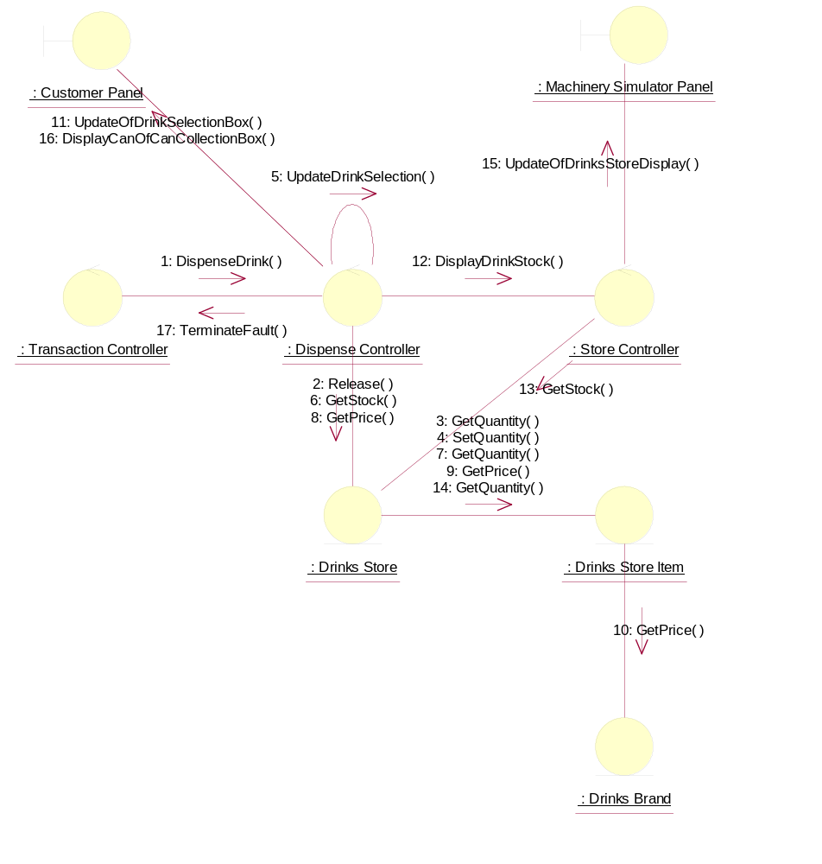

Participating Objects
: Customer Panel
This panel simulates the vending machine's customer interface panel. It will enable the user (the Customer) to:
1 insert coins;
2 select brands;
3 terminate transaction.
It will also provide the following display functions:
1 display total money inserted;
2 indicate coin not valid;
3 indicate no change available;
4 display the value of the change to be collected;
5 display an icon representing the dispensed drink.

: Dispense Controller
This control object is for handling the dispense drink use case.
: Drinks Brand
This entity object stores the name of the drink brand and it's price. There can be as many drink brands as we desire, for a particular configuration.
: Drinks Store
The object is storage, in the vending machine's memory, for the total number of cans of each Drinks Brand held by the vending machine.
: Drinks Store Item
This represents a column of drinks in the vending machine. It can store a drink of any particular brand type.There can be as many drink store items as we desire in the vending machine. This number will be a configurable item for the vending machine.
: Machinery Simulator Panel
This panel simulates the physical actions of the maintainer. It enables the user to:
1 display and enter new values for the number of cans of each Drinks Brand held by the Drinks Store;
2 display and enter new values for the number of Coins of each denomination held by the Cash Store;
3 display whether the vending machine Door is unlocked, and enable it to be locked.

: Store Controller
This object controls the Change State use case. It mangages changes in Cash Store attributes and the Drinks Store attributes. It also handles the door status. It is also used by the Dispense Drink use case to update the Drinks Store attributes.
: Transaction Controller
This control object coordinates the customer transactions for selection of a drink brand, coin input, storage of coins and termination requests for ongoing transactions.

Class Diagrams

Class Diagram: Dispense Drink
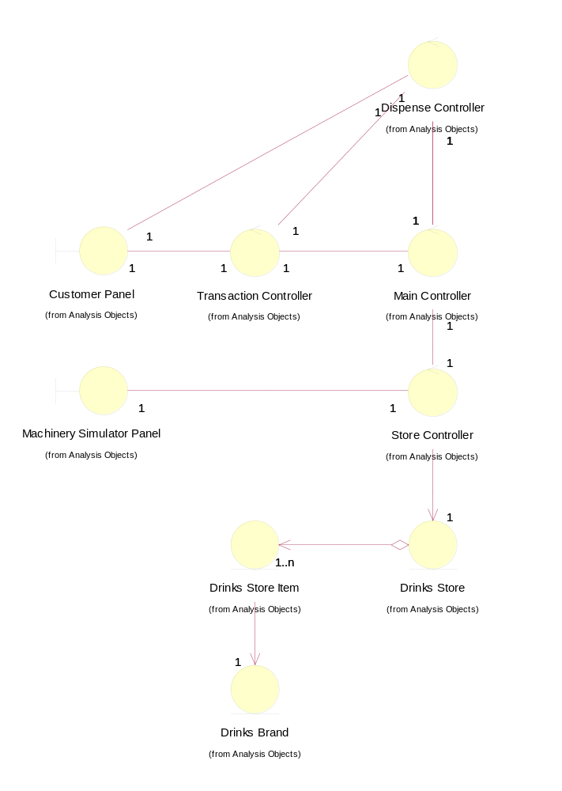

Derived Requirements
There are no special requirements associated with host implementation. However, in the target implementation, a drinks receiving tray is required to be built into the Customer Panel.

